10yr LIMITED WARRANTY AND LIMITATION OF LIABILITY
MISSISSIPPI METAL MFG.
STEEL ROOFING AND SIDING PANELS.
THIS WARRANTY COVERS THRIFTY MATERIAL ONLY.

Our paint for our Thrifty products will not crack, check or peel (Lose adhesion) for ten (10) years. This does not include minute fracturing that may occur in proper fabrication of the building parts.

In case of a complaint, you will provide access to us and assist us as necessary in determining the exact cause of the failure; ASTM and NCCA testing procedures will be used.

If our thrifty steel fails to comply with our limited warranty, we will pay for materials reasonably necessary to repaint, repair or replace, at our option the building part showing the failure. In order for the warranty to be in effect, however, you must notify us in writing of the failure within thirty days of the discovery of such problem and provide documentation we may require. If we repaint, we will use normal painting practices using the same paint, or other suitable alternatives. This warranty also applies to the part we repainted, repaired, or replaced, but only for the unexpired portion of the warranty period applicable to the original part.
Our LIMITED WARRANTY DOES NOT APPLY to circumstances that we do not control:
a. Fire or other casualty or physical damage;
b. Unusual harmful fumes or foreign substance in the atmosphere, i.e., animal confinement, acid rain;
c. The misapplication of the thrifty product,
d. Improper treatment of or defects in the metal or in the fabrication, i.e., wet metal in bundle; and
e. Mishandled products, i.e., ANY PRODUCT, WHICH HAS BEEN ABUSED, ALTERED, MODIFIED, USED IN A MANNER NOT ORIGINALLY INTENDED OR STORED CONTRARY TO OUR INSTRUCTIONS.
This warranty will apply only to metal that is coated with our thrifty paint system and used on property located within the Continental United States.

The coil coating has a limited shelf life. So this warranty applies only to material applied by you within six (6) months after it is shipped to Mississippi Metal Mfg.. As long as the steel has been stored inside in a dry space.

For our warranty to apply, you must maintain certain records. You need to make them available to us for inspection and copying. These may include:
  - Mississippi Metal Mfg. Work Order Verifications
  - Mississippi Metal Mfg. Invoices
  - Any other records necessary to identify our thrifty products that gives proof of purchase date, quantity and price.

We need to make clear that this is our only warranty concerning our thrifty steel. So, please read and understand the following:

DISCLAIMER OF WARRANTY, EXCEPT AS EXPRESSLY PROVIDED ABOVE, MISSISSIPPI METAL MFG. MAKES NO REPRESENTATION OR WARRANTY EXPRESS OR IMPLIED, WITH RESPECT TO THE THRIFTY PRODUCT’S PAINT SYSTEM INCLUDING, WITHOUT LIMITATION, ANY WARRANTY AS TO MERCHANTABILITY OR ANY OTHER MATTER.
LIMTATION OF LIABILITY, MISSISSIPPI METAL MFG. SHALL HAVE NO LIABILITY TO ANY PERSON OR INCIDENTAL, CONSEQUENTIAL OR SPECIAL DAMAGES OF ANY DESCRIPTION, WHETHER ARISING OUT OF WARRANTY OR OTHER CONTRACT, NEGLIGENCE OR OTHER TORT OR SET FORTH HEREIN ARE AGREED ALLOCATIONS OR RISK AND SHALL SURVIVE THE DETERMINATION OF ANY COURT OR COMPETENT JURISDICTION THAT THE REMEDY PROVIDED HEREIN FAILS OF ITS ESSENTIAL PURPOSE.
That is our complete warranty. It set out all of our obligations regarding the Thrifty panels. It is only for your benefit and is not assignable. It cannot be changed by such things as your purchase order forms or our acceptance forms. But it can be changed if Mississippi Metal Mfg. agrees in writing.
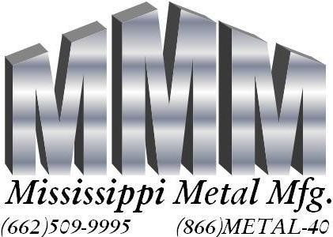

● 451 Hwy 9 South, Pontotoc, MS 38863 
Effective: April 1, 2006

